Mini Project Report on

RTO MANAGEMENT SYSTEM

Submitted by
Drishti Gandhi
Harshad Barapatre
Kuljot Chadha

Guided by
Prof. Nilesh Rathod

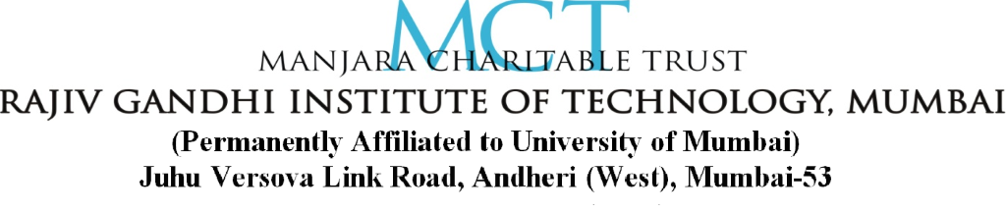
DEPARTMENT OF INFORMATION TECHNOLOGY

UNIVERSITY OF MUMBAI

2019-2020
CERTIFICATE

Date: ___________

This is to certify that, the mini project work embodied in this report entitled, “RTO MANAGEMENT SYSTEM” submitted by “Drishti Gandhi bearing Roll No. 617”, “Harshad Barapatre bearing Roll No. 608”, “Kuljot Chadha bearing Roll No. 609” for the award of Third Year in Bachelor Of Engineering(B.E.) degree in the subject of Software Engineering and Project Management in Information Technology, is a work carried out by them under my guidance and supervision within the institute. The work described in this mini project report is carried out by the concerned students and has not been submitted for the award of any other degree of the University of Mumbai.
Further, it is certified that the students were regular during the academic year 2019-2020 and have worked under the guidance of concerned faculty until the submission of this mini project work at Rajiv Gandhi Institute of Technology, Mumbai.

Prof. Nilesh Rathod
Project Guide
Dr. Sunil B. Wankhade  Head of Department | Dr. Sanjay U. Bokade  Principal

CERTIFICATE OF APPROVAL

This Mini Project Report entitled
RTO MANAGEMENT SYSTEM

Submitted by:
DRISHTI GANDHI 617
HARSHAD BARAPATRE 608
KULJOT CHADHA 609

In partial fulfillment of the requirements of the degree of Third year in Bachelor of Engineering in Information Technology is approved.

Internal Examiner

_____________________
SEAL OF
INSTITUTE External Examiner

_____________________

DECLARATION

I declare that this written submission represents my ideas in my own words and where others' ideas or words have been included, I have adequately cited and referenced the original sources. I also declare that I have adhered to all principles of academic honesty and integrity and have not misrepresented or fabricated or falsified any idea/data/fact/source in my submission. I understand that any violation of the above will be cause for disciplinary action by the Institute and can also evoke penal action from the sources which have thus not been properly cited or from whom proper permission has not been taken when needed.

ROLL NO. | NAME | SIGNATURE
617 | DRISHTI GANDHI
608 | HARSHAD BARAPATRE
609 | KULJOT CHADHA

Date:
Place:

ACKNOWLEDGEMENT

With all reverence, we take the opportunity to express our deep sense of gratitude and wholehearted indebtedness to our respected guide, Prof. Nilesh Rathod, Department of Information Technology, Rajiv Gandhi Institute of Technology, Mumbai. From the day of conception of this project, his active involvement and motivating guidance on day-to-day basis has made it possible for us to complete this challenging work in time.
We would like to express a deep sense of gratitude to our respected Head of the Department, Dr. Sunil B. Wankhade, who went all the way out to help us in all genuine cases during the course of doing this project. We wish to express our sincere thanks to Dr. Sanjay Bokade, Principal, Rajiv Gandhi Institute of Technology, Mumbai and would to like to acknowledge specifically for giving guidance, encouragement and inspiration throughout the academics.
We would like to thank all the staff of Information Technology Department who continuously supported and motivated during our work. Also, we would like to thank our colleagues for their continuous support and motivation during the project work. Finally, we would like to express our gratitude to our family for their eternal belief in us. We would not be where we are today without their support and encouragement.

DRISHTI GANDHI
HARSHAD BARAPATRE
KULJOT CHADHA

Date:
Place:

ABSTRACT

RTO management system project is prepared for RTO office to maintain all records like 2-wheeler registration, 3-wheeler registrations, learning license and driving license, changing of address, renewal form and much more. These are the main activities of RTO office. The administrator is a power user, he has the power to verify the data and provide appropriate solutions. By introducing the new system, we have been organized some striking facilities. Registration of vehicle through online. Fancy number selection of vehicles through online. Issues of information about the licence, which includes application forms and license test and other information. In the existing system of RTO office perform functions such as registration, license and fitness. Regional transport office is the organization of the Indian government responsible for maintaining a database of vehicles for various states of India. The RTO issues driving licenses organizes a collection of vehicle excise duty and sells personalized registrations. These are the main activities of RTO office; we developed this software application with a fully computerized method to manage all the data. At present all records are maintained manually.

TABLE OF CONTENTS

CHAPTER 1: INTRODUCTION 1
CHAPTER 2: AIM & OBJECTIVES 2
  - Aim of the Project 2
  - Objectives of the System 2
CHAPTER 3: EXISTING SYSTEM 3
CHAPTER 4: PROBLEM STATEMENT 4
CHAPTER 5: METHODOLOGY 5
CHAPTER 6: DETAILS OF HARDWARE & SOFTWARE 8
6.1 Minimum Hardware Requirement 8
6.2 Software Requirement 8
- Java 8
- SQL 9
CHAPTER 7: PROPOSED SYSTEM 10
7.1 Project Design 10
7.2 Architectural Design 11
- Architectural Context Diagram 11
- Control Hierarchy 12
7.3 Interface Design 12
7.4 Activity Diagram for User 18
7.4 Data Design 19
CHAPTER 8: SCOPE & LIMITATIONS 20
CHAPTER 9: CONCLUSION 21
REFERENCES 22

TABLE OF FIGURES

Figure 5.1: The Prototyping Model 6
Figure 7.1: Architectural Context Diagram 11
Figure 7.2: Control Hierarchy Diagram 12
Figure 7.3: Activity Diagram 18

